0

CERTIFICATE

To Whomsoever it may concern

This is to certify that the following students have completed their 1st year Web Development Training project at Chandigarh University for Academic year 2018-19.

**The Project Details Are as below:**

Project Title : Gamer’s Heaven

Project Guide :  
University Name : Chandigarh University,Gharuan.

Branch : B.E.(CSE)

**Name Of Students:**

1. Aditya Thakur

For Chandigarh University

Dr. Vikas Wason

HOD- CSE Department(AU-2)

**Acknowledgement**

I would liketo express my heartfelt gratitude to Chandigarh University for giving me the opportunity to work under their guidance and help me gain immensely enriching professional experience.My sincere thanks to my Internal Guides Miss Tanu Dhiman (Ass. Professor) and Miss Bindu Rani (Ass. professor) for giving me valuable inputs and Ideas right from the selection topic for project till its successful completion.

I thank Prof. Vikas Wason (HOD CSE department) for his continuous support in providing facilities and encouragement in every aspect.

The successful completion of my project would not have been possible without the dedicated support from all mentors,friends and family.

Aditya Thakur

**Table of Content**

1. Introduction…………..…..……………………………………..1
2. Tools and Technologies Used……………………………………2
3. Snapshots…………………………………………………….. 2-9
4. Result and Discussion…………………………………………10
5. Future Plans……………………………………………….……11
6. Conclusion…………………………………………………….12
7. References…………………………………………………….14

**Introduction to Project**

The project is based upon development of a gaming website using technologies like HTML-5,CSS,Javascript and bootstrap.Th project namely 'Gamer's Heaven' is all about games. The Navigation bar indicates various consoles like PC,XBOX-360,PS-2 etc and clicking of each leads to the games section compatible with the choosen device. The Navbar also consists of the category dropdown which consists of various categories of games such as Arcade,FPS etc.Clicking on any leads to the choosen type of games.

Then there are the top picked games by the editor.

The games are displayed in cards with a ‘Know more’ button which further leads to more info about the game and also provides the download link.

There is a section of upcoming games where the most awaited upcoming games are displayed with their status.

Then there is form for registration so that user can sign-up for more free and exciting stuff.At last there are links of the accounts of project on various social website for User’s to follow.

The Website is made look more attractive using parallax,corousel ,icons and navigation bar.

1.

**TOOLS AND TECHNOLOGIES**

**USED**

* HTML-5
* CASCADING STYLE SHEET(CSS)
* JAVA-SCRIPT
* BOOTSTRAP
* MICROSOFT VISUAL CODE EDITOR
* FONTAWESOME TOOLKIT
* GOOGLE CHROME

**2**

**SNAPSHOTS**

* **HOME PAGE**

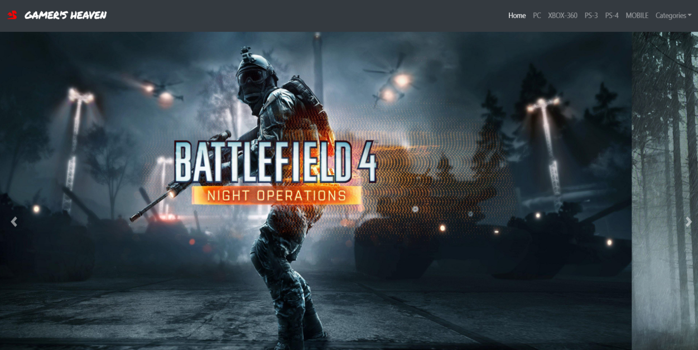

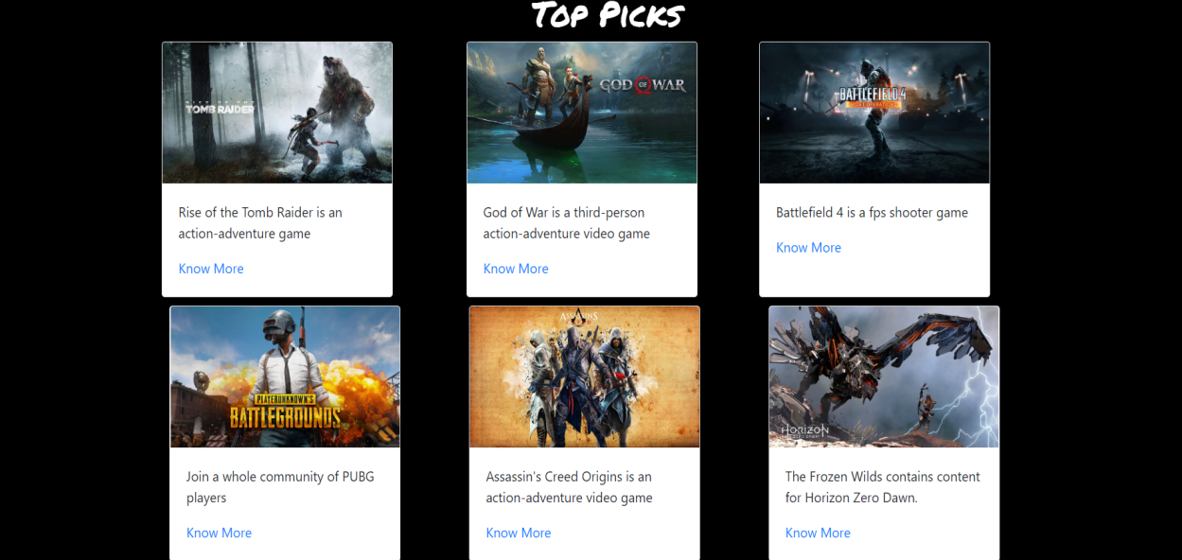

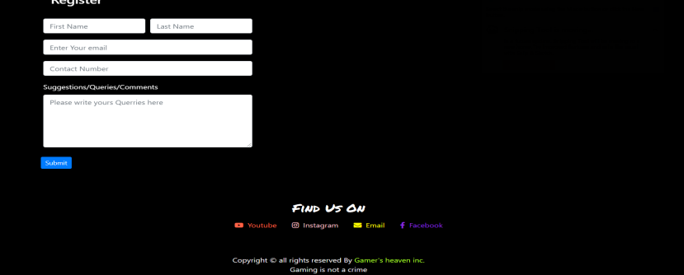

**3.**

**Sub-Categories**

* **PC**

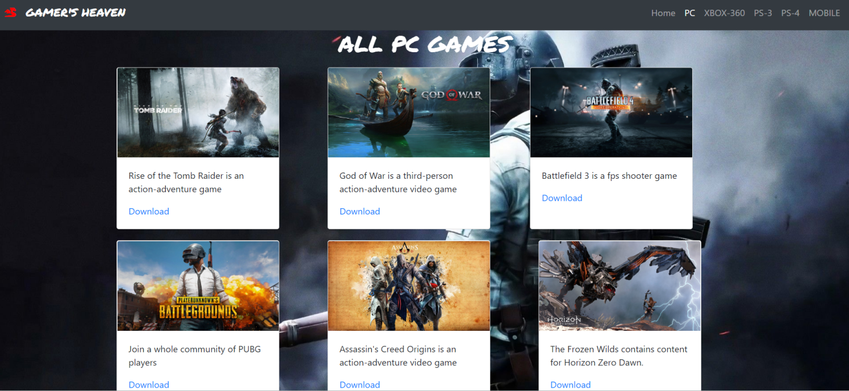

* **XBOX-360**

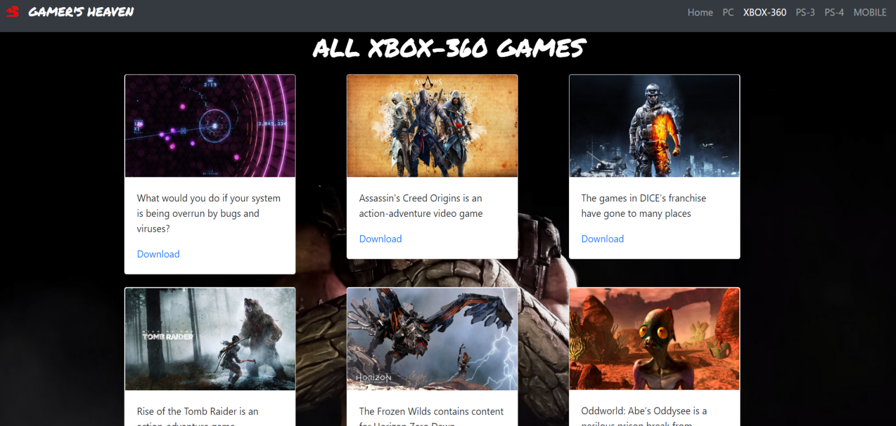

**4**

* **PS-3**

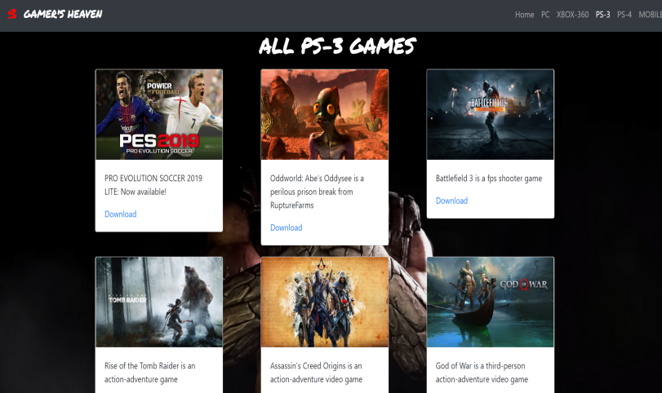

* **PS-4**

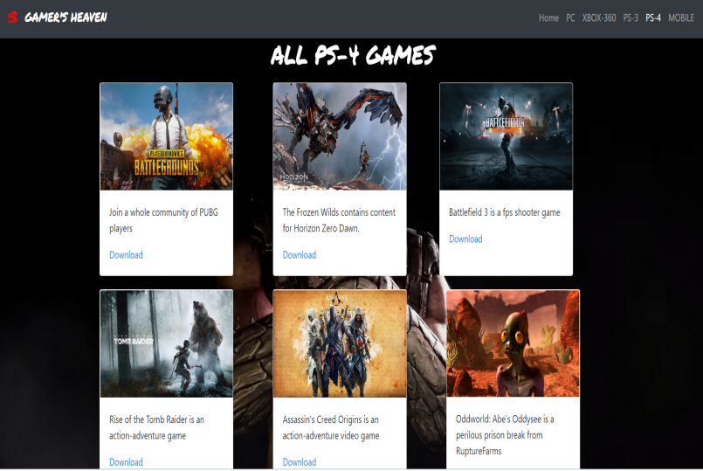

**5**

* **Mobile**

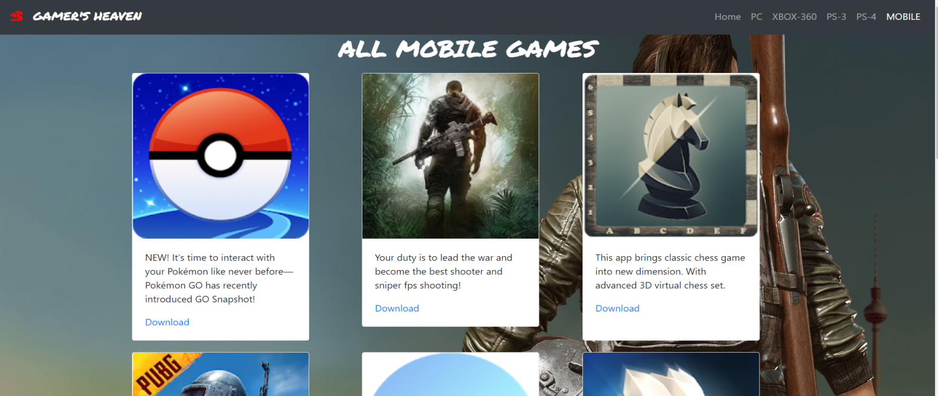

* **Classic**

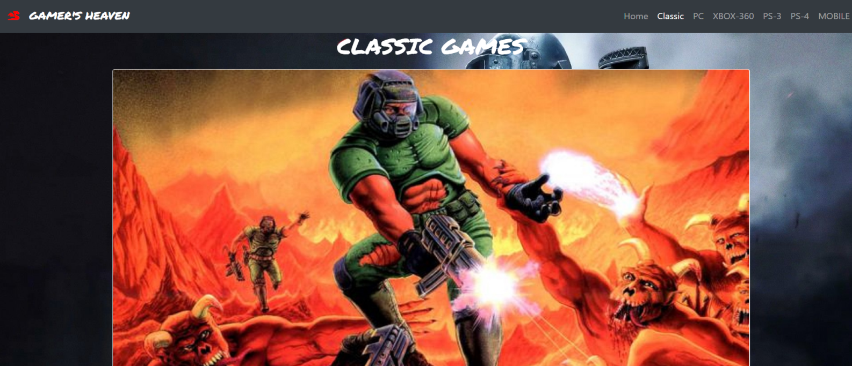

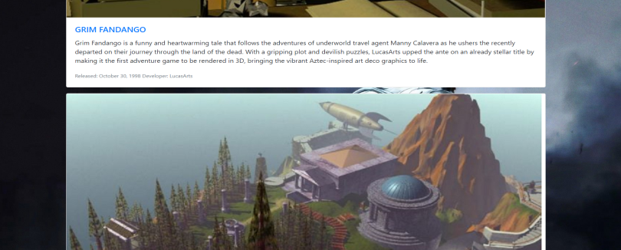

**6**

* **Arcade:**

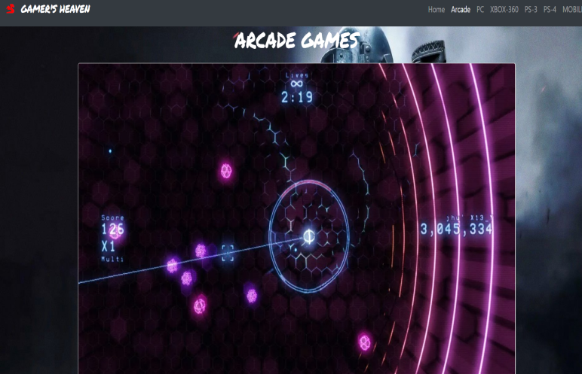

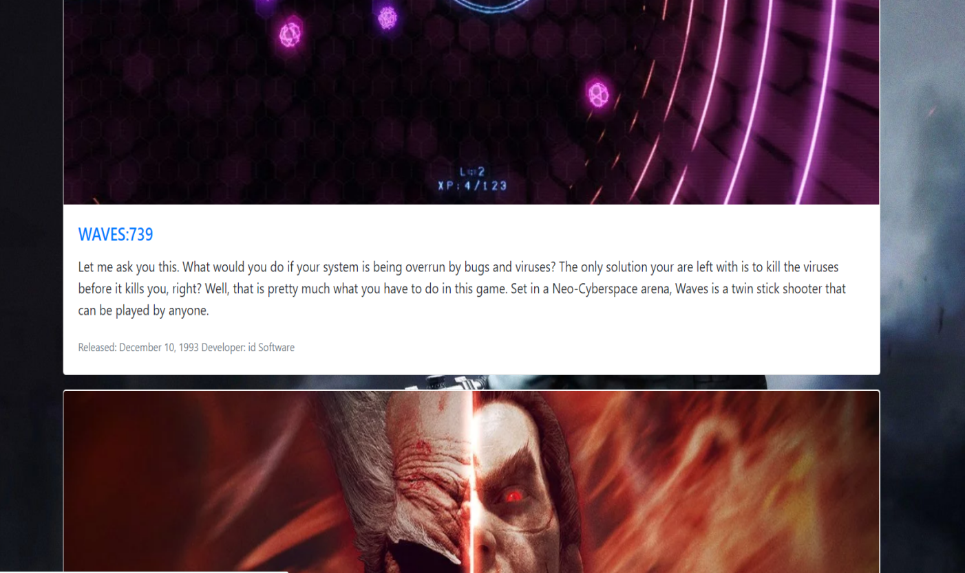

**7**

* **FPS**

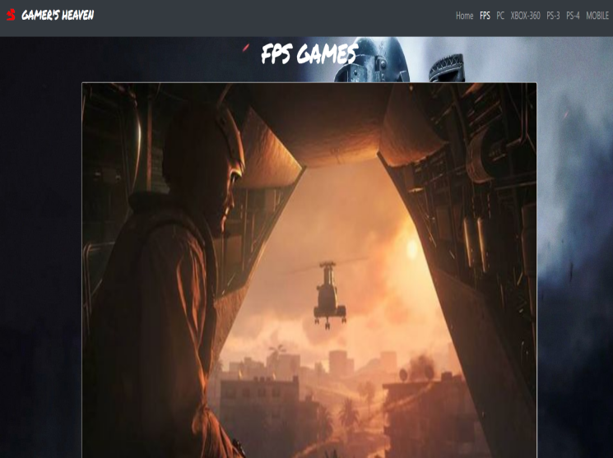

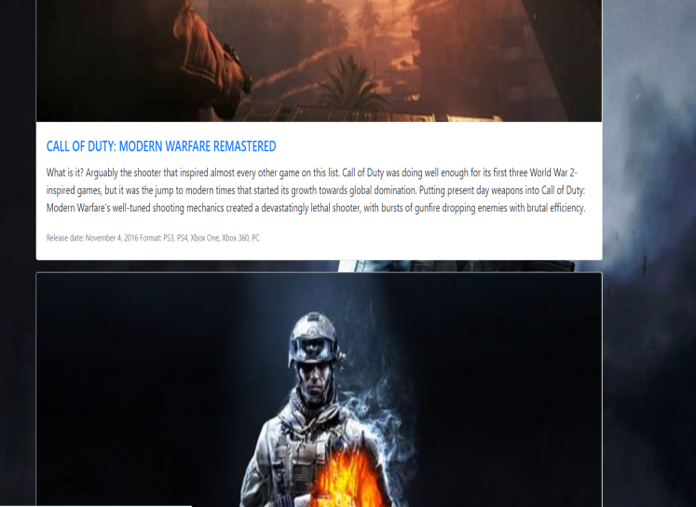

**8**

* **Sports**

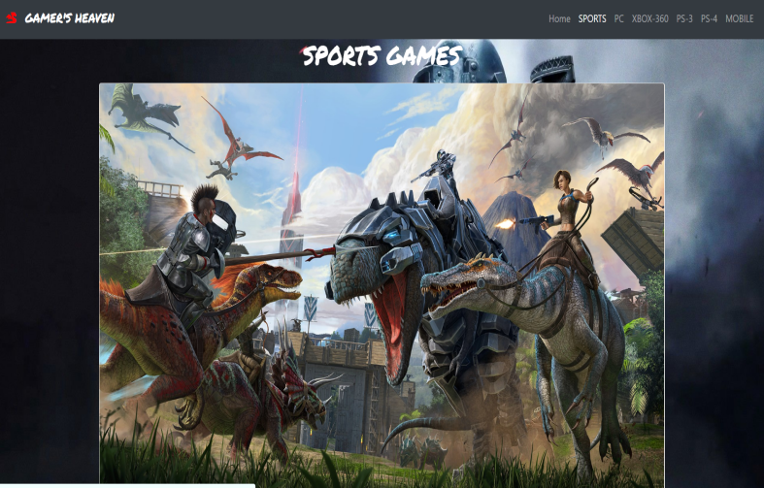

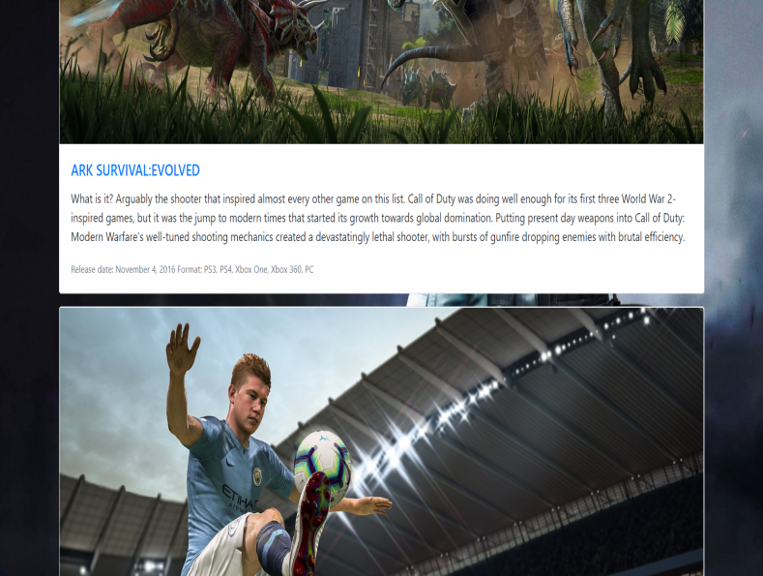

**9**

**Result and discussions**

The following are some result drawn from the project development process and major topics are also discussed as follows:

1. HTML-5 is the most used language is the project. It is the base language and all the basic content and designing is done with HTML.
2. CSS and Javascript are designer languages .They have been used to design the website ,its content and its various sections. 
3. Every category and Every page needs its own ‘.html’and ‘.css’ files in order to show content properly and give new design to every page. 
4. Various websites such as Bootstrap and fontawesome further helps in designing the webiste as they provide various cards designs and fonts which can be used to make project look attractive.
5. Various attributes such as the nav-bar , the parallax, the corousell, the registration form are essesntial parts of dominant project website. 
6. Defining categories and compatible sources adds to more user-friendly experience to the website.
7. Adding follow links such asYoutube channel link and other social media platform links leads to greater growth of the channel.

10

**Future plans**

* To improve the Graphical and User Interface of the Website.
* To Add more categories to the categories section.
* To provide direct download links to the games displayed.
* To Add more games.
* To make partnership with other gaming websites and enhance scope
* To make the website more User friendly
* Adding A separate feedback Form.
* To provide a separate section for providing Tech-news.
* To Add paid games.
* To provide a separate search section for users to search their favorite games.

11

**Conclusion**

The purpose and Objective of Gamer’s Heaven is achieved. By providing extremely rich graphical user interface,web page designing is easy and in aesthetic form. Flexibility in designing makes user explore their imagination and thus ,even a novice user can dream and accomplish their wish of web designing.

12

**REFERENCES**

* <https://getbootstrap.com/>
* <https://www.google.co.in/>
* [https://www.youtube.com](https://www.youtube.com/)
* <https://www.oldpcgaming.net/crazy-taxi/>
* <https://fonts.google.com/?selection.family=Permanent+Marker>
* <https://www.gamesradar.com/best-fps-games/3/>
* <https://fontawesome.com/>
* <https://play.google.com/>
* <https://install-game.com/>

13